Robot mars priority inversion problem: <https://www.cse.chalmers.se/~risat/Report_MarsPathFinder.pdf>

Page 5 gives good example of going to shit

High priority – switches the switch 1s every 2s

Medium Priority – move train 4s every 4s task

Low priority – read train locations 4s repeat task

With switch controlled by mutex

If priority inversion occurs, train will keep moving and crash as turning signal won’t change in time

//= = = = = = = = = = = = = =

[Incoming train> = = = = = Y = = = = = [waiting train>

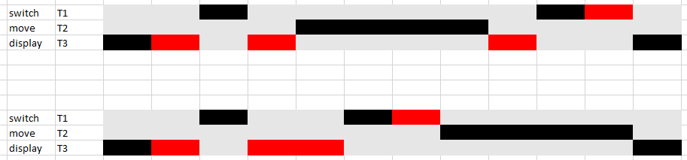

High – print values in buffer

Medium – print a few ---

Low – send values to buffer